Theory questions

Module 1

Git clone is used when you want to copy a repository from GitHub to your computer for the first time. It downloads the complete project along with its history.
Git fetch is used to check and download the latest changes from the remote repository without changing your local files. It lets you review the updates before merging them.
Git pull is used when you want to update your local repository with the latest changes from GitHub. It downloads the changes and merges them into your current branch automatically.

.gitignore file tells Git which files and folders should not be tracked or uploaded to the repository. It is mainly used to ignore generated files, temporary files, operating system files, and IDE-specific configuration files that are not required in the project.

# Compiled output files
*.hex
*.elf

# OS-specific files
.DS_Store
Thumbs.db

# IDE folders
.vscode/
build/

Module 2
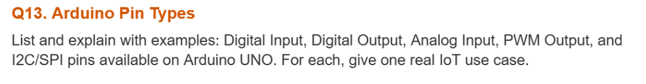

1. Digital Input
Digital input pins are used to read only two values, HIGH or LOW. These pins are useful for taking input from devices like push buttons or switches.
Example: Push Button
IoT Use Case: A smart door lock can use a push button or magnetic switch to detect whether the door is open or closed.

2. Digital Output
Digital output pins send HIGH or LOW signals to control external devices.
Example: LED
IoT Use Case: In a smart home, an Arduino can turn an LED or a relay ON and OFF remotely.

3. Analog Input
Analog input pins can read different voltage levels and convert them into digital values (0–1023).
Example: Potentiometer
IoT Use Case: A soil moisture sensor connected to an analog pin can measure soil moisture in a smart irrigation system.

4. PWM Output
PWM (Pulse Width Modulation) pins are used to control devices like LEDs and motors by varying the duty cycle. Arduino Uno has PWM pins 3, 5, 6, 9, 10 and 11.
Example: LED Brightness Control
IoT Use Case: PWM can be used to control the speed of a DC fan based on room temperature.x

5. I2C / SPI Pins
I2C and SPI are communication interfaces used to connect Arduino with sensors, displays and other modules.
I2C Pins: SDA (A4), SCL (A5)
SPI Pins: MOSI (11), MISO (12), SCK (13), SS (10)
Example: OLED Display
IoT Use Case: An IoT weather station can send temperature and humidity data to an OLED display using I2C.

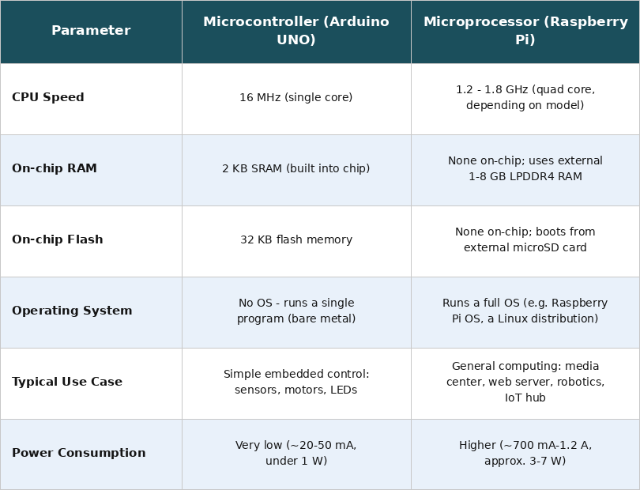
analogRead() is used to read analog values from sensors connected to the analog input pins. It converts the input voltage into a digital value between 0 and 1023.
analogWrite() is used to generate a PWM (Pulse Width Modulation) signal on PWM pins. It accepts values from 0 to 255 to control the output level.
PWM is a technique in which a digital pin switches ON and OFF very quickly to simulate an analog output. It is used to control devices such as LEDs and motors smoothly.
A practical IoT example of analogRead() is reading data from a soil moisture sensor in a smart irrigation system. A practical IoT example of analogWrite() is controlling the brightness of an LED street light or the speed of a DC fan based on sensor readings.

The setup() function runs only once when the Arduino starts or is reset. It is used to initialize pins, sensors and serial communication.
The loop() function runs continuously after setup() and contains the main program logic.
If a long delay() is placed inside loop(), the Arduino waits during that time and cannot perform any other task. As a result, sensor readings become slow and the system responds late to changes.
A better alternative is to use the millis() function. It allows different tasks to run without stopping the program, making the system more responsive and suitable for IoT applications.

Module 3
Sensor calibration means adjusting a sensor so that it gives correct and accurate readings. It is important in IoT systems because wrong sensor values can lead to incorrect decisions and poor system performance.
Two-point calibration method:
- First, place the soil moisture sensor in dry soil and note the sensor value (Dry value).
- Then place the sensor in fully wet soil and note the sensor value (Wet value).
- Use these two values to map any future sensor reading into a 0–100% moisture percentage.
This method makes the soil moisture readings more accurate and reliable.

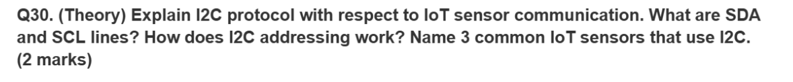

I2C (Inter-Integrated Circuit) is a communication protocol used to connect a microcontroller with multiple sensors using only 2 wires.
- SDA (Serial Data Line): Used to transfer data between the microcontroller and sensors.
- SCL (Serial Clock Line): Provides the clock signal to synchronize data transfer.
I2C Addressing:
Each I2C device has a unique address. The master (Arduino/ESP32) sends the address of the required sensor, and only that sensor responds while the others ignore the communication.
Examples of I2C IoT Sensors:
- BMP280 (Temperature & Pressure Sensor)
- MPU6050 (Accelerometer & Gyroscope)
- BH1750 (Light Intensity Sensor)

